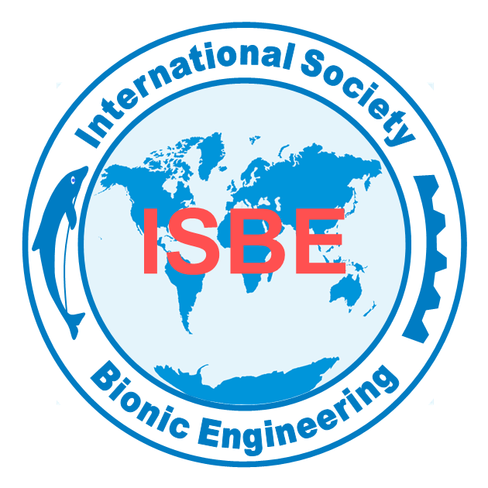
EXCELLENT MEMBERSHIP APPLICATION
INTERNATIONAL SOCIETY OF BIONIC ENGINEERING (ISBE)
Family Name |  | Given Name |  | Photo
Gender |  | Date of birth |  | Photo
Affiliation |  |  |  | Photo
Research field |  | Title |  | Photo
Telephone |  | Email |  | Photo
Address
ACADEMIC ACHIEVEMENTS IN THE FIELD OF BIONIC ENGINEERING
Summary of the research accomplishments including representative publications, major honors or awards

CONTRIBUTIONS TO THE ISBE
Engagement in the ISBE activities including conferences, workshops, competitions, newsletters, wechat platform etc.

Signature: Date:
Please complete this Form and send to us by e-mail, mail or fax as shown below:
Address: ISBE Secretariat, C508 Dingxin Building, Jilin University, 2699 Qianjin Street, 130012, Changchun, P.R. China.
Tel: 86-431-85166507 Fax: 86-431-85166507 E-mail: secretariat@isbe-online.org;gyue@isbe-online.org

