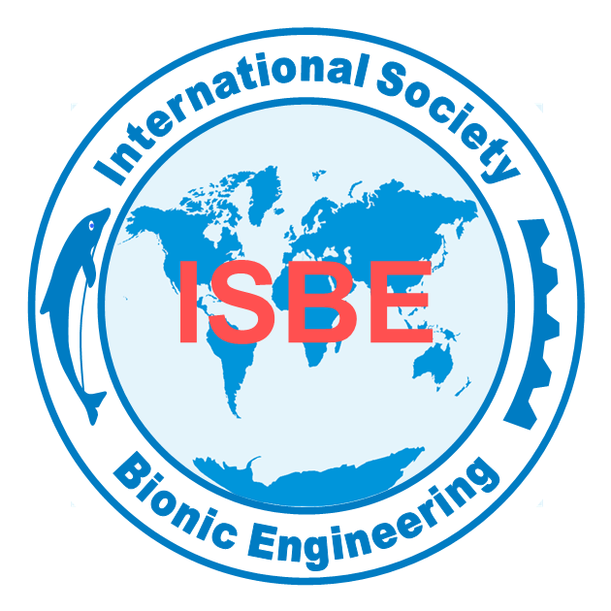
APPLICATION FORM
INTERNATIONAL BIONIC ENGINEERING AWARD
Name |  | Nationality |  | Photo
Gender |  | Date of Birth |  | Photo
Affiliation |  |  |  | Photo
Research Field |  | Job Title |  | Photo
Telephone |  | Email |  | Photo
Contact Address
Award applied for | □ Outstanding Contribution Award  □ Outstanding Youth Award  □ Outstanding Student Award
SUMMARY OF THE ACCOMPLISHMENTS in the field of bionic engineering (300 words or less)
REPRESENTATIVE PUBLICATIONS (Books/Papers) with indication of impact (10 or less)
1.

2.

3.

4.

5.

6.

7.

8.

9.

10.

AWARDS & HONORS (5 or less)：
1.
2.
3.
4.
5.
INVITED PLENARY or KEYNOTE LECTURES (5 or less)：
1.
2.
3.
4.
5.
GRANTED PATENTS (5 or less):
1.
2.
3.
4.
5.
CONTRIBUTIONS TO THE ISBE (100 words or less):
Engagement in the ISBE activities including conferences, workshops, competitions, newsletters etc.

Signature: Date:
Note: All data should be included in this form. The proof materials including the book cover, title page, and related certificates shall be provided together with the application form.
Address: ISBE Secretariat, C508 Dingxin Building, Jilin University, 2699 Qianjin Street, 130012, Changchun, P.R. China.
Tel: 86-431-85166507 Fax: 86-431-85166507 E-mail: xmtian@isbe-online.org; secretariat@isbe-online.org

